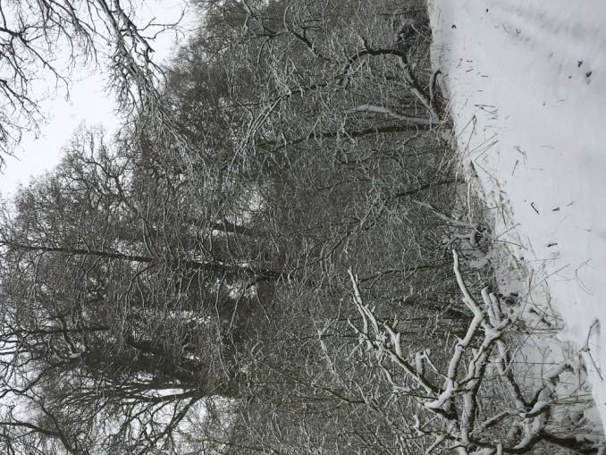

- We follow Chirton CoE Primary School for our school closures.
- Please listen to Heart radio or check out their website for school closures. If it says Chirton School, we will be closed as well.
- The Gazette and Herald also has a list of schools that are closed.
- Please have a look at our Facebook page. We will put any school closures on there.
- We will try to contact all parents of children who are in on the day of the closure, but please be aware that text messages don’t always come through.

