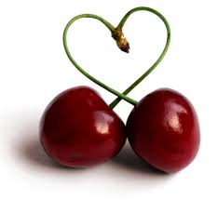

Starting at

Chirton Pips Pre-school

with Forest School Sessions

January 2021

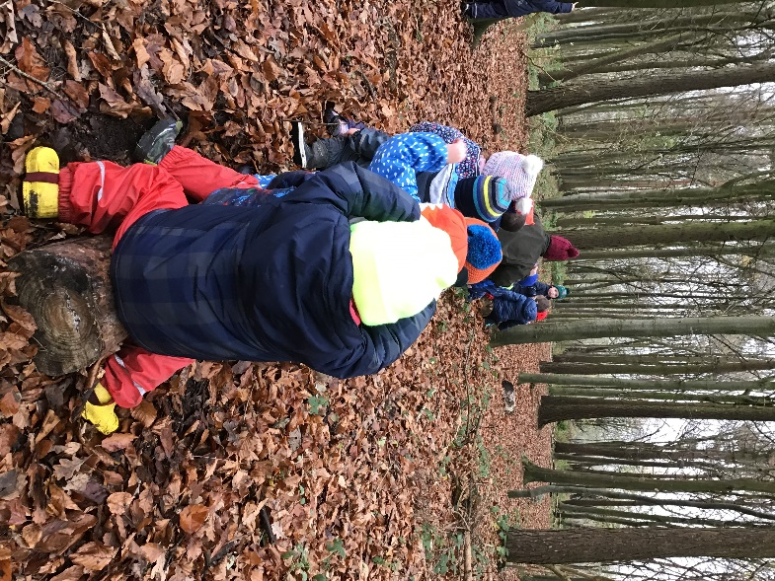

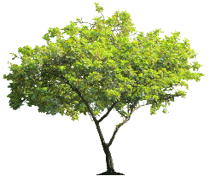

Chirton Pips Pre-school
The Street, Chirton
Devizes, Wiltshire, SN10 3QS
Tel: 07910195330 E-mail chirtonpips@hotmail.co.uk

Dear Parent / Carers

We would like to welcome you to Chirton Pips Pre-school and hope that you and your son/daughter will enjoy your time with us. Just a reminder that we are outside every day, so please do ensure that your child has a complete change of clothes including socks and pants with their waterproof clothes and wellingtons.
Please can you bring in your son/ daughters Birth Certificate to the stay and play session on 4th January 2021. We need to see it so we are able to claim their funding.
We have put together some information for you to share with your son or daughter, we hope that by looking at it together they become familiar with the staff and room.
We have also attached our Welcome Pack. This gives you some more information about Pips and what you need to bring with you. Please note that the guidance from the government at the moment is that children can only attend one setting.
If you have any questions please don’t hesitate to contact us.
We hope that you have a very Happy Christmas

The Pips Team x

The Team

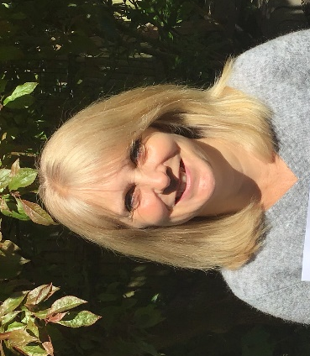

Sarah Tina

Penny Louisa

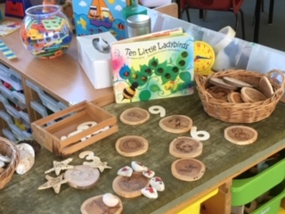
Inside Pips
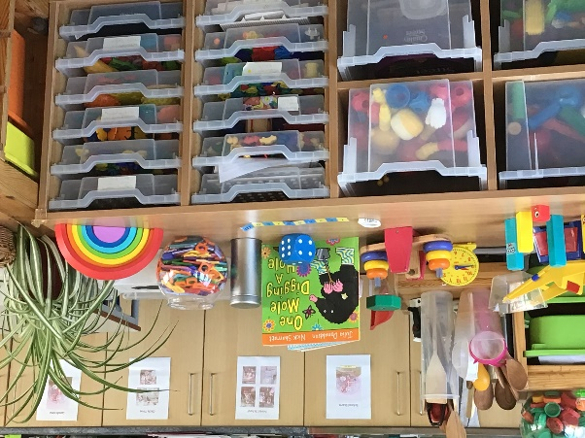

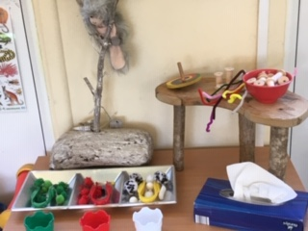
Our maths areas
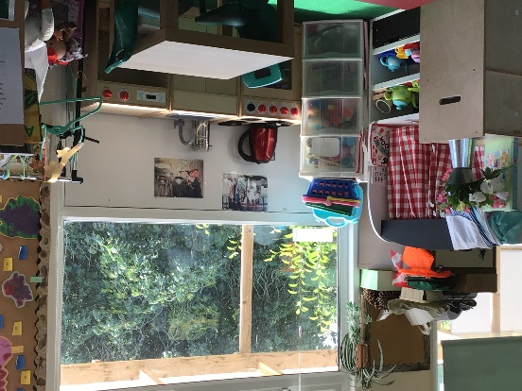

Fine motor skills area
The home corner

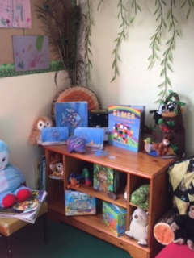
Our reading area

Pips Garden
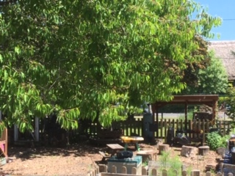

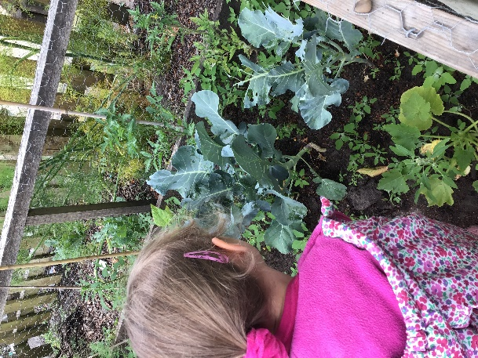
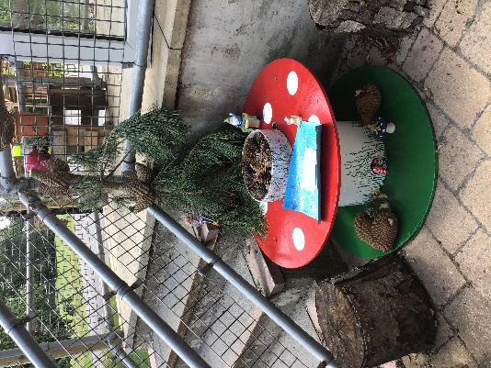
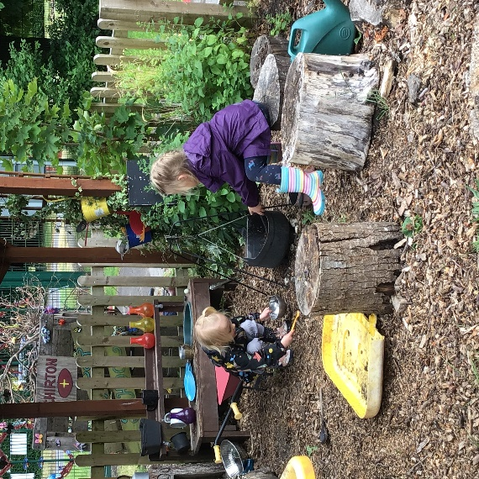
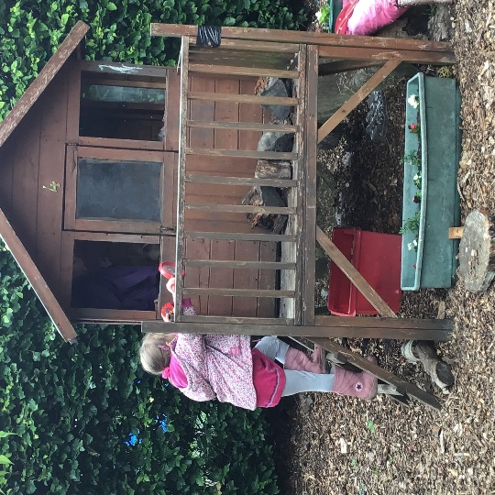

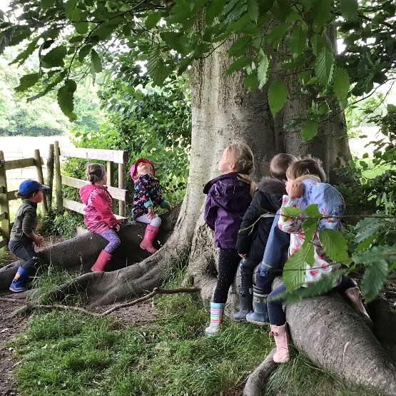
The Woods

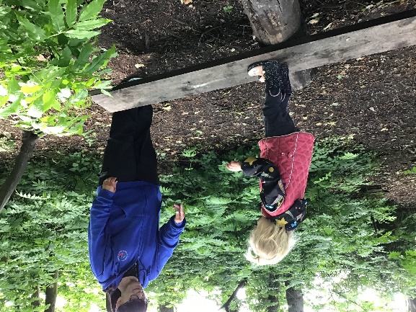

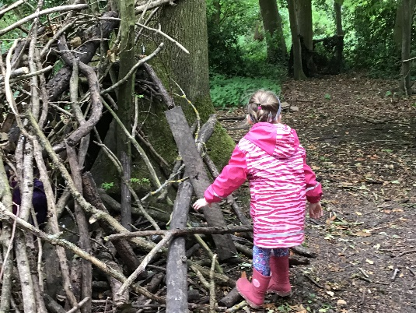

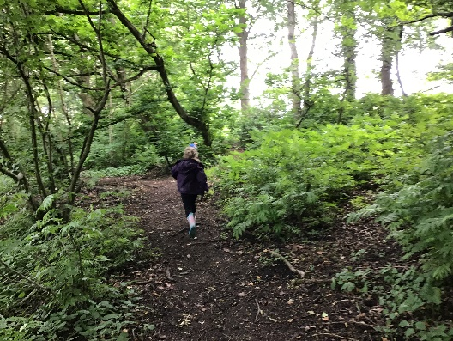

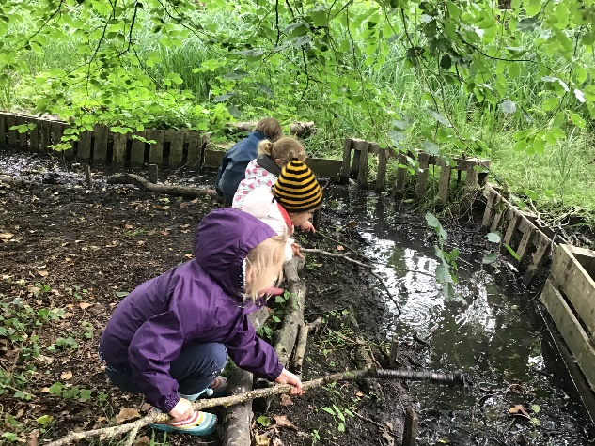
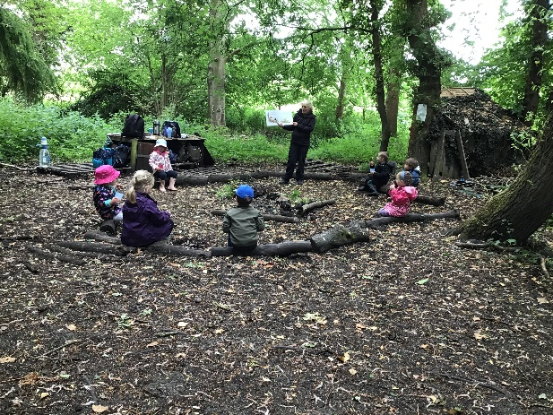

The Essentials!
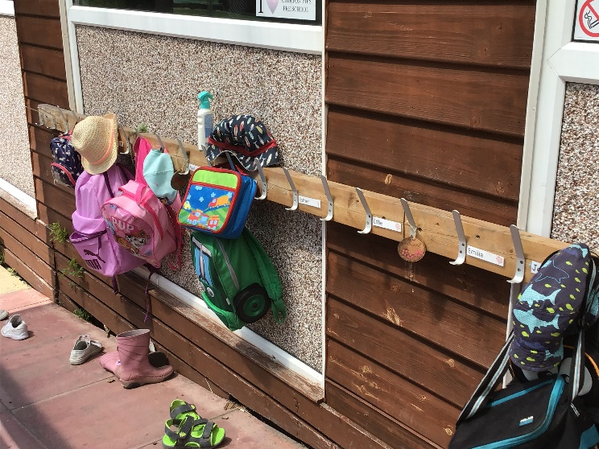
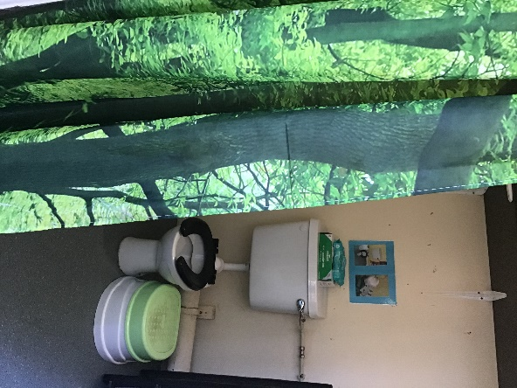
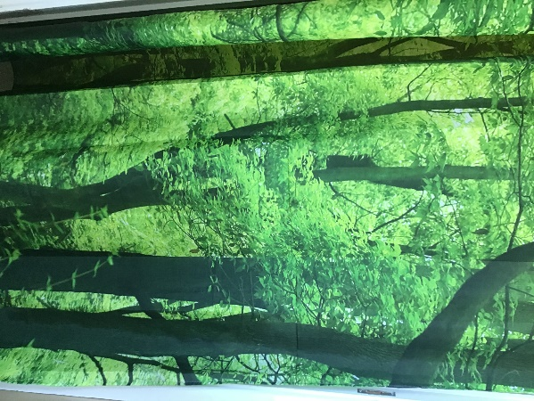
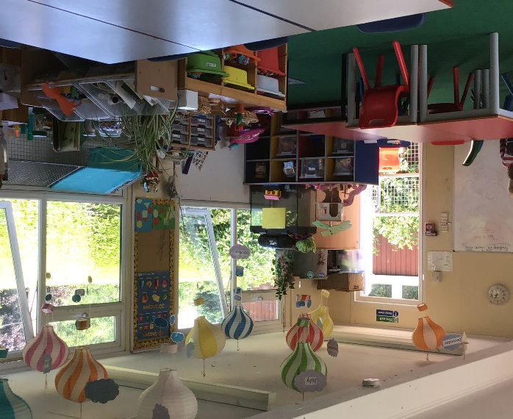
Behind the curtain is our ‘little’ toilet. A special one just the right size for children.
Our playroom
We hang our coats and bags up outside on the ramp.

One of our favourite activities is making a play dough, here is the recipe that we use.

NO-COOK PLAY DOUGH RECIPE
You need:
- 2 cups plain flour (all purpose)
- 2 tablespoons vegetable oil (baby oil and coconut oil work too)
- 1/2 cup salt
- 2 tablespoons cream of tartar
- 1 to 1.5 cups boiling water (adding in increments until it feels just right)
- gel food colouring (optional)
- few drops glycerine (my secret ingredient for stretch and shine!)
Method
- Mix the flour, salt, cream of tartar and oil in a large mixing bowl
- Add food colouring TO the boiling water then into the dry ingredients
- Stir continuously until it becomes a sticky, combined dough
- Add the glycerine (optional)
- Allow it to cool down then take it out of the bowl and knead it vigorously for a couple of minutes until all of the stickiness has gone. * This is the most important part of the process, so keep at it until it’s the perfect consistency! *
- If it remains a little sticky then add a touch more flour until just right.

Playdough is an activity that is GREAT for: developing fine motor skills and muscle strength (needed for writing later on!), recognising circles, understanding that combining materials can create new substances, sensory exploration, pretend play, imaginative skills, language and role play, understanding basic maths.
